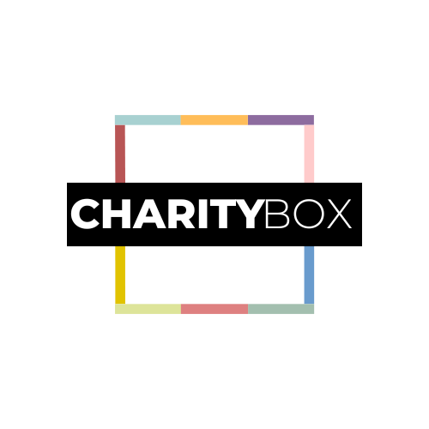

**Website**: [www.charityboxhq.com](http://www.charityboxhq.com)

**Email**: [charityboxhq@gmail.com](mailto:charityboxhq@gmail.com)

Welcome to **Charity**Box!

Thank you for choosing **Charity**Box templates to assist your nonprofit organization.

At **Charity**Box we empower nonprofits through affordable resources and expert guidance, enabling charities to create sustainable and lasting impacts in their communities.

We're thrilled to share these resources with you and are excited to see how they will contribute to your nonprofit’s growth and success!

**Make the most of your Charity**Box **template(s).**

1. Open the templates using your preferred software or program

(i.e. Word, Google Docs).

1. Familiarize yourself with the structure and contents.
2. Tailor the content, colors, and styles to match your nonprofit’s brand identity.
3. Customize the templates with your nonprofit's specific information, including logo, contact details, mission, etc.

**We're Here for You!**

If you need assistance, our dedicated support team is ready to help.

Contact us at [charityboxHQ@gmail.com](mailto:charityboxHQ@gmail.com).

**Exclusive Use and Terms of Purchase**

We kindly request that you use these templates exclusively for your nonprofit organization. Sharing, distributing, or reselling **Charity**Box templates without proper purchase limits our ability to offer these templates at affordable rates.

For more information, reference our [Terms & Conditions](https://www.charityboxhq.com/copy-of-privacy-policy).

Thank you again for choosing **Charity**Box. We're honored to be part of your journey

**Cheers!**

**Charity**Box

P.S. Need more templates? Visit [www.charityboxHQ.com](http://www.charityboxhq.com).

We regularly update the **Charity**Box library based on user and member requests!

**Nonprofit Website SEO Checklist**

By following this nonprofit website SEO checklist, your organization can optimize its online presence, improve search engine rankings, and reach a wider audience. Remember that SEO is an ongoing process, and staying up-to-date with best practices and industry trends is vital to maintaining strong visibility in search results. With a well-optimized website, your nonprofit can attract more supporters, donors, and volunteers to further its mission and make a positive impact in the community.

* **Keyword Research:**
* Identify relevant keywords related to your nonprofit's mission, programs, and services.
* Use tools like Google Keyword Planner or Ubersuggest to find popular and relevant keywords.
* **Page Titles:**
* Include the primary keyword for each page in its title tag.
* Keep titles unique, descriptive, and within 50-60 characters.
* **Meta Descriptions:**
* Write compelling meta descriptions for each page that include relevant keywords and summarize the content.
* Keep meta descriptions under 160 characters to ensure they display properly in search results.
* **URL Structure:**
* Keep URLs short, descriptive, and include target keywords.
* Use hyphens to separate words in the URL.
* **Header Tags:**
* Use appropriate header tags (H1 for main title, H2 for subheadings, etc.) to organize content.
* Include relevant keywords in headings to improve SEO.
* **Content Optimization:**
* Create high-quality, informative, and relevant content on each page.
* Use variations of target keywords naturally throughout the content.
* Aim for comprehensive and helpful content that answers users' questions.
* **Internal Linking:**
* Include internal links throughout your website to connect related pages.
* Internal linking enhances user navigation and helps search engines understand site structure.
* **Image Optimization:**
* Optimize images by using descriptive filenames with relevant keywords.
* Add alt text to images to provide context for users and search engines.
* **Mobile Responsiveness:**
* Ensure your website is mobile-friendly and displays properly on smartphones and tablets.
* Mobile-friendly sites are favored by search engines and improve user experience.
* **Page Loading Speed:**
* Optimize page loading speed by compressing images and leveraging browser caching.
* Fast-loading pages improve user experience and search engine rankings.
* **Schema Markup:**
* Implement schema markup to provide structured data that helps search engines understand your nonprofit's content better.
* Schema markup can enhance rich snippets in search results, increasing visibility.
* **Social Media Integration:**
* Integrate social media sharing buttons to allow visitors to share your content easily.
* Social signals can indirectly impact search rankings and drive traffic.
* **Sitemap and Robots.txt:**
* Create and submit an XML sitemap to search engines to facilitate crawling and indexing.
* Use a robots.txt file to control which parts of your website are accessible to search engines.
* **SSL Certificate:**
* Install an SSL certificate to secure your website with HTTPS.
* HTTPS is a ranking factor, and it also builds trust with visitors.
* **Page Redirects:**
* Implement 301 redirects for any outdated or broken links to ensure a smooth user experience and preserve SEO value.
* **Local SEO (if applicable):**
* Include local information (address, phone number) on your website to improve local search visibility.
* Register your nonprofit with Google My Business and other local directories.